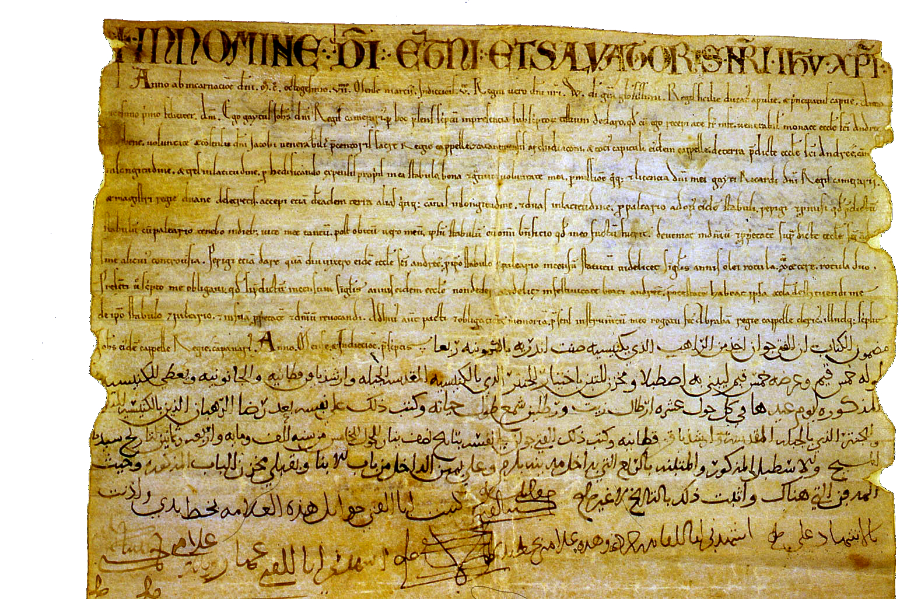
Documenting Multiculturalism
in Norman Sicily and the Islamicate East

A workshop organised by the Khalili Research Centre at Wolfson
Friday 29 November — The Buttery, Wolfson College
9:30 Registration, coffee and croissants
10:00—10:30
Documenting Multiculturalism in Norman Sicily: a brief introduction to the project
Jeremy Johns (KRC, Oxford)
10:45—11:15
“Persian in Documents” and “Going Local in the Perso-Islamic Lands”: the Afghan Geniza, islamisation and language in the pre-Mongol Islamicate East: a brief introduction to the two projects
Arezou Azad (KRC, Oxford)
11:30—12:00
The DocuMult database: cataloguing, tagging, and interrogating the multilingual documents of Norman Sicily
Daniel Burt (KRC, Oxford)
12:15—12:45
Persian Land Sale Documents from the Archive of Yehuda ben Daniel
Ofir Haim (Jerusalem)
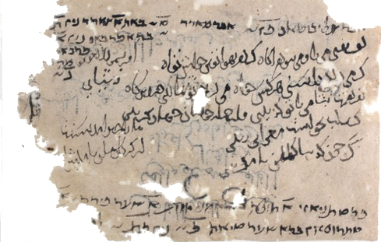
1:00—2:00 Lunch

2:00–2:30
The anathema as penalty clause. A good example of plurality of iura in Sicily during the Norman period.
Marta Cerrito (Palermo)
2:45–3:15
The documents of Norman Sicily as a source for the study of Medieval Greek
Francesca Vuturo (Palermo)
3:30–4:00
The opus sectile Arabic inscriptions of the Norman palaces: style and context.
Umberto Bongianino (KRC, Oxford)
4:15–4:30 Tea
4:30–5:00
Zaynab the captive: the Norman dīwān and the ransom of Muslim prisoners held by foreign Christian powers
Nadia Jamil (Oriental Studies, Oxford)
5:15–5:45
“Occidit, occidit spes omnis, et fortuna nostri nominis”: the Banū Raǧāʾ qāḍīs of Norman Palermo
Jeremy Johns (KRC, Oxford)
6:00 Closing remarks, drinks and canapés
For further information please email ruth.macdonald@humanities.ox.ac.uk

- All papers will be for 30 minutes, followed by up to 15 minutes for discussion

- The workshop is open to all but, for reasons of space, places are strictly limited to 30, so prior reservation by email is essential. Please reserve a place before Friday 22 November by completing the form below and sending it to to ruth.macdonald@humanities.ox.ac.uk

- The workshop will be recorded and published as soon as possible on the KRC website

Documenting Multiculturalism in Norman Sicily and the Islamicate East
Reservation Form
Please return no later than Friday 22 November
ruth.macdonald@humanities.ox.ac.uk

Full name

College/Department/Faculty

Emai
l
I wish to lunch with the other participants in Wolfson Hall. I understand that I must pay for my own lunch and bring the card (Wolfson/debit/credit) necessary to do so. |  |  |  |  | YES / NO  Please delete one
If you have a particular interest in attending the workshop (e.g. you are a research student working on comparable corpora of medieval documents, or on comparative medieval law), please briefly describe your interest.

If, having reserved, you subsequently find that you are unable to attend, please cancel immediately so that your place can transferred to someone on the waiting list.

